**Literature Reviews**

Note for sources:

→ Google Scholar, Scopus, IEEE Explore, DBLP, ACM Digital Library ⇒ UCD Digital Library

1. **A Review of Traffic Congestion Prediction Using Artificial Intelligence**

[A Review of Traffic Congestion Prediction Using Artificial Intelligence](https://www.hindawi.com/journals/jat/2021/8878011/)

→ Highly Relevant data and approach to my project

→ Published in 2021, so still relevant conceptually but perhaps slightly outdated

→ Broad data collection

~ Various international cities (USA, Asia)

~ Stationary Data collection - Sensor and Fixed Camera

~ Probe Data - GPS data mounted on various vehicles

Proposed layout of traffic congestion prediction system:

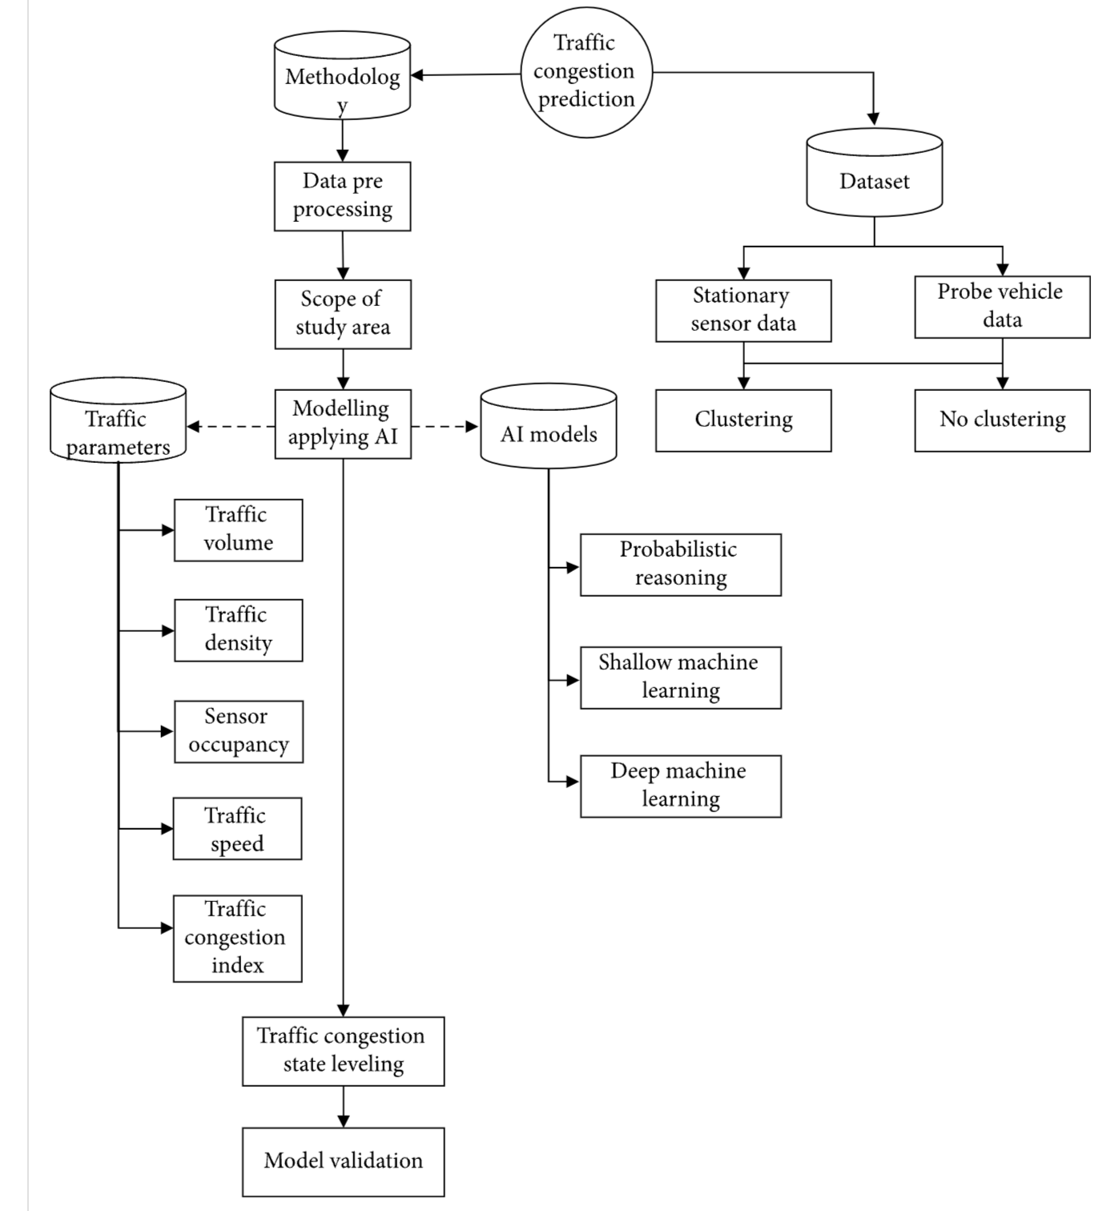

Some studies use clustering the acquired data before applying the main congestion models of prediction.

Clustering algorithms are a type of unsupervised ML technique used to group similar data points together in a dataset. The primary purpose of this is to discover hidden patterns, structures or relationships within the data, without any prior knowledge of what those patterns might be

This hybrid modelling technique is applied to fine-tune the input values and use them in the training phase. Something like this:

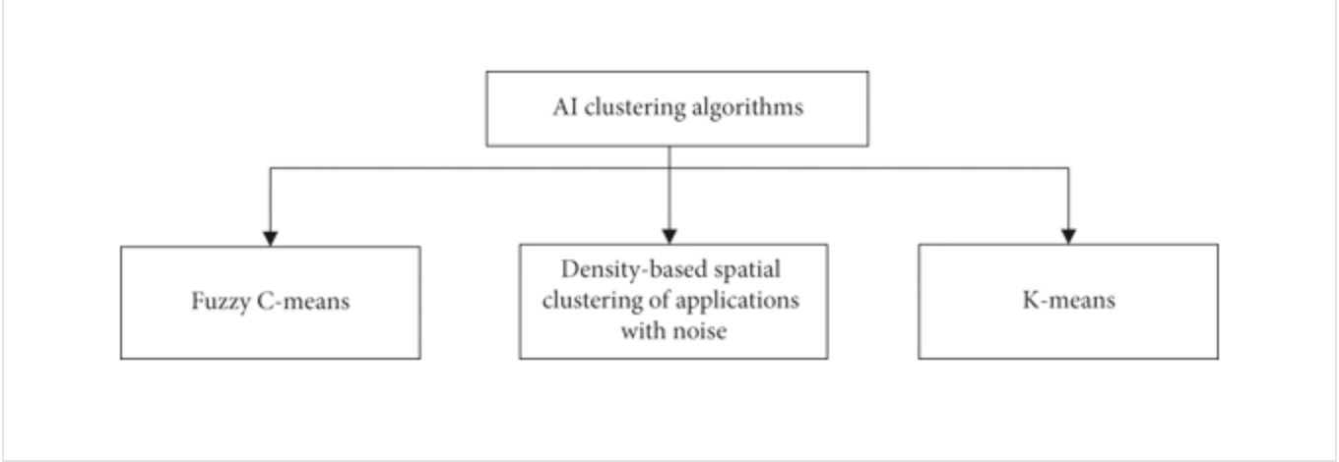

* K-Means clustering is an effective and flexible algorithm when dealing with large datasets (i.e 1M+)
  + Used for overcoming the limitations and exploted the pattern using principal component analysis (PCA)
    - [Dimension Reduction](https://www.notion.so/Dimension-Reduction-4001f8f0bf9a4463bf3a72fbc5269f11?pvs=21)
* DBSCAN
  + More general clustering application in ML and DM. Used to overcome the limitation of FCM of predefining the cluster number
  + Automatically generate arbitrary cluster shapes surrounding by clustering of different characteristics and can easily recognise outliers.
* Fuzzy Means (FCM)
  + Popular nondeterministic clustering technique in data mining
  + Used to deal with missing or incomplete data as it can overcome the issue of getting trapped in the local optimum  
      
     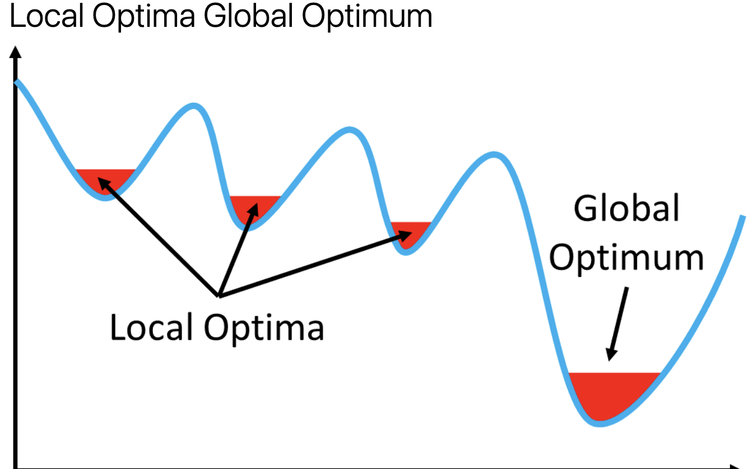

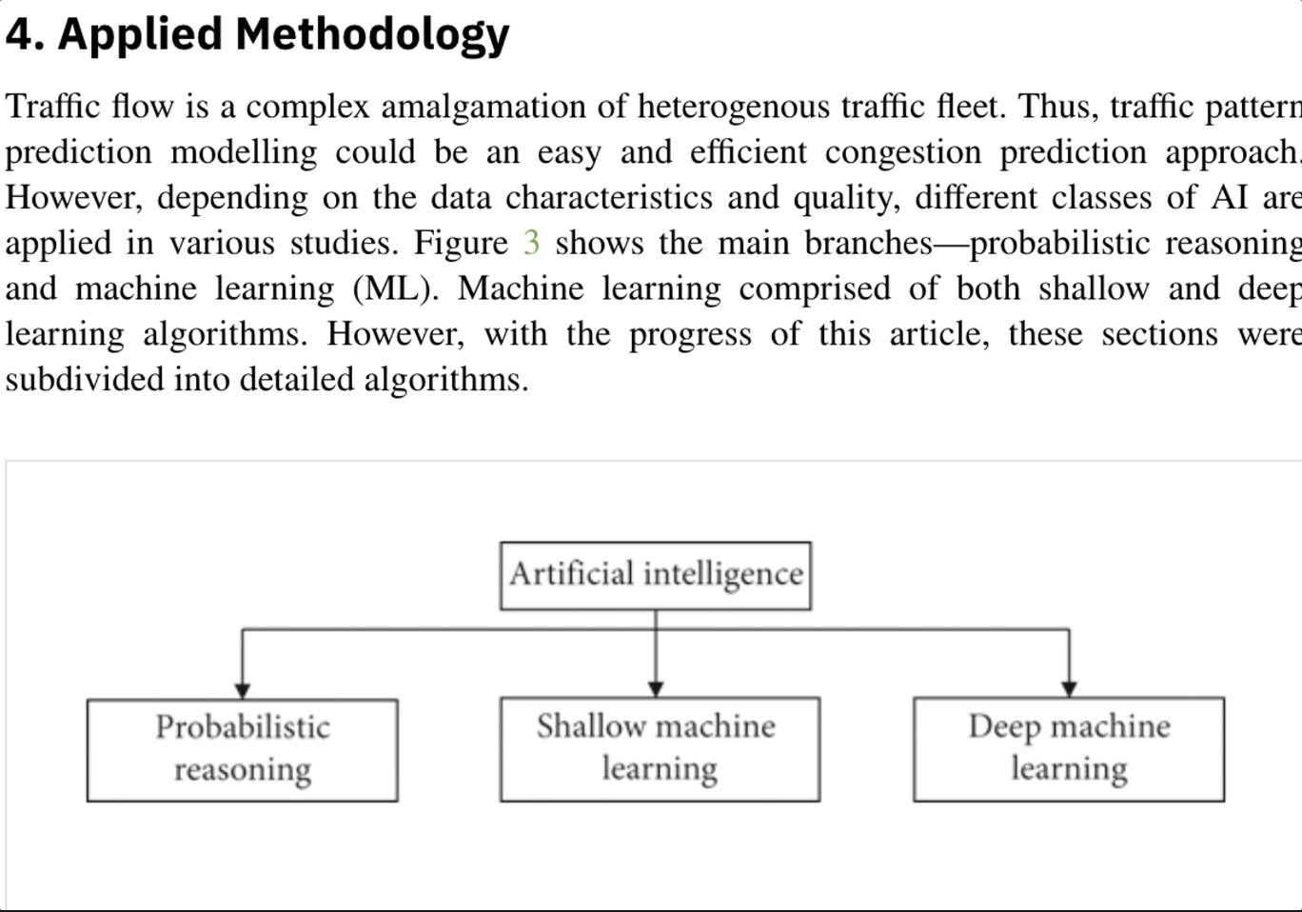

Methodology Methods:

* Artificial Neural Network
* Decision Tree
* Deep Machine Learning
* Support Vector Machines
* Gaussian Distribution
* Fuzzy Logic?

**Citation:**

****TY - JOUR

A2 - Bazant, Michael

AU - Akhtar, Mahmuda

AU - Moridpour, Sara

PY - 2021

DA - 2021/01/30

TI - A Review of Traffic Congestion Prediction Using Artificial Intelligence

SP - 8878011

VL - 2021

AB - In recent years, traffic congestion prediction has led to a growing research area, especially of machine learning of artificial intelligence (AI). With the introduction of big data by stationary sensors or probe vehicle data and the development of new AI models in the last few decades, this research area has expanded extensively. Traffic congestion prediction, especially short-term traffic congestion prediction is made by evaluating different traffic parameters. Most of the researches focus on historical data in forecasting traffic congestion. However, a few articles made real-time traffic congestion prediction. This paper systematically summarises the existing research conducted by applying the various methodologies of AI, notably different machine learning models. The paper accumulates the models under respective branches of AI, and the strength and weaknesses of the models are summarised.

SN - 0197-6729

UR - <https://doi.org/10.1155/2021/8878011>

DO - 10.1155/2021/8878011

JF - Journal of Advanced Transportation

PB - Hindawi

KW -

ER -

1. **Artificial Intelligence Traffic Analysis Framework for Smart Cities**

[Artificial Intelligence Traffic Analysis Framework for Smart Cities](https://link.springer.com/chapter/10.1007/978-3-031-37717-4_45#citeas)

→ Seems like it contains very relevant information, issues with Access with Institution to access full document

→ More focused on safety of drivers, but delves into using AI to analyse traffic performance

→ Very recent, 2023

**Citation:**

****TY - CONF

AU - Tarawneh, Monther

AU - AlZyoud, Faisal

AU - Sharrab, Yousef

ED - Arai, Kohei

PY - 2023

DA - 2023//

TI - Artificial Intelligence Traffic Analysis Framework for Smart Cities

BT - Intelligent Computing

SP - 699

EP - 711

PB - Springer Nature Switzerland

CY - Cham

AB - The use of artificial intelligence and the transfer to smart cities assist in improving the mobility inside them by enhancing the traffic flow and decreasing the number of traffic accident deaths. There have been many studies to handle traffic management in urban cities by modifying the main dimensions for smart cities in mobility management and benefiting from artificial intelligence in intelligent decision-making. The use of network to build infrastructure for smart city is a major factor in successful smart city. This will enable running variety of application the use of unlimited space and data analysis using cloud edge computing. Vehicles become smart to run smartly in smart city. However, the safety of driver is the main concern and remote monitoring of driver and vehicles is the only way to have smart city without accidents. In this research, we propose a framework that analyze traffic data on time to reduce the number of accidents and safe people lives. The framework makes use of IoT devices and artificial intelligence diagnose the driver, car performance and road condition. The simulation shows that the proposed framework is great help in saving driver’s life by monitoring it remotely, great help in watching car performance to reduce cost and prevent damage to the car. In addition to that, it can be used by driver to check road status and by government to control traffic.

SN - 978-3-031-37717-4

ID - 10.1007/978-3-031-37717-4_45

ER -



3)**Traffic Monitoring and Management System for Congestion Control using IoT and AI**

[**Traffic Monitoring and Management System for Congestion Comtrol using IoT and AI**](https://ieeexplore.ieee.org/document/10053260)

→ “Intelligent Transportation System, robust vehicle tracking, and on-road traffic information systems can help break logjams, thus improving travel. Also, this reduces loopholes in traffic management and creates a positive approach to road mobility”

~ Really relevant datasets, concept and ideas

→ November 2022, recent, not outdated

This paper also discusses comparative analysis. In addition to ongoing research, existing works in line with traffic-related anomalies have provided a way forward and smart-traffic resolutions. A few of analyses of search works are summarised in the table below:

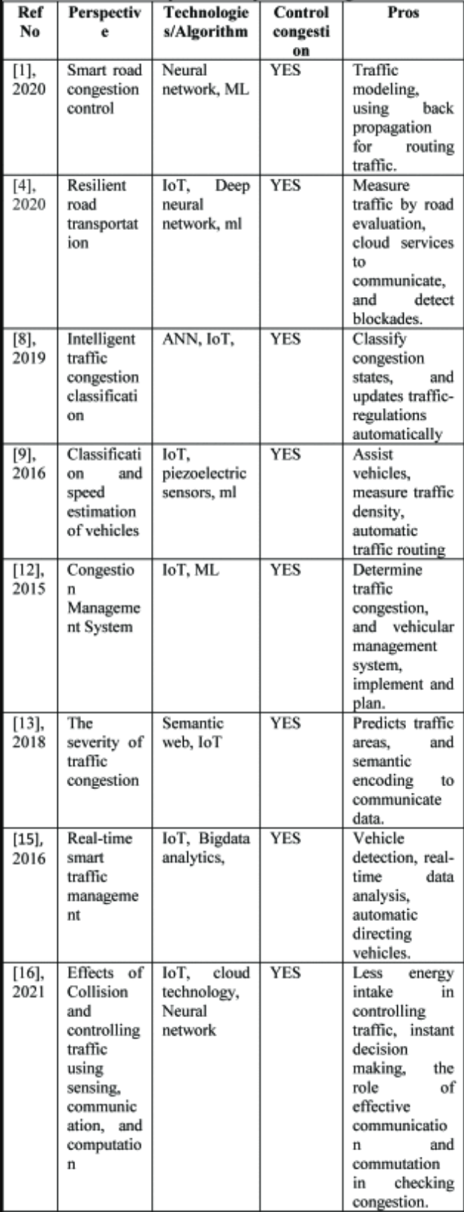

→ Methodology is noteworthy, shares similarities to what we previously discussed

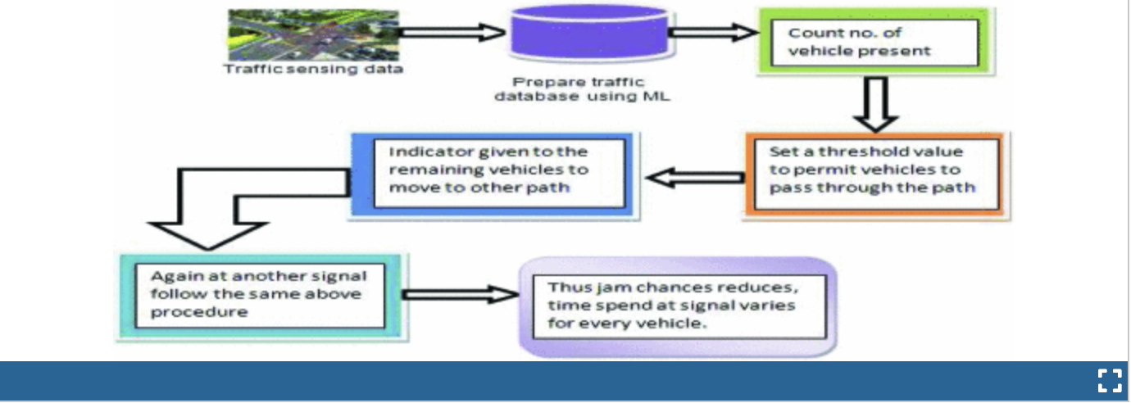

→ “The model presented in this paper can modify itself dynamically to suit the changes desired to ease traffic jams” ~ worth considering these approaches in my own project

**Citation:**

****TY - CONF

TI - Traffic Monitoring and Management System for Congestion Comtrol using IoT and AI

T2 - 2022 Seventh International Conference on Parallel, Distributed and Grid Computing (PDGC)

SP - 641

EP - 646

AU - A. Larhgotra

AU - R. Kumar

AU - M. Gupta

PY - 2022

DO - 10.1109/PDGC56933.2022.10053260

JO - 2022 Seventh International Conference on Parallel, Distributed and Grid Computing (PDGC)

IS -

SN - 2573-3079

VO -

VL -

JA - 2022 Seventh International Conference on Parallel, Distributed and Grid Computing (PDGC)

Y1 - 25-27 Nov. 2022

ER -

1. **Intelligent Traffic Monitoring, Prioritising and Controlling Model based on GPS**

[**Intelligent Traffic Monitoring**](https://ieeexplore.ieee.org/document/10100296)

→ “With the increasing global population and emerging technologies, there is a pressing need for efficient traffic management systems. Unfortunately, the traditional traffic control system, which relies on tri-colour signals is unable to prioritise emergency vehicles or control traffic effectively. Resulting in accidents, loss of life, and traffic congestion”

~ Very similar motivation and approach to my own project

→ 2023, Very recent and relevant

→ Interesting prototype concepts

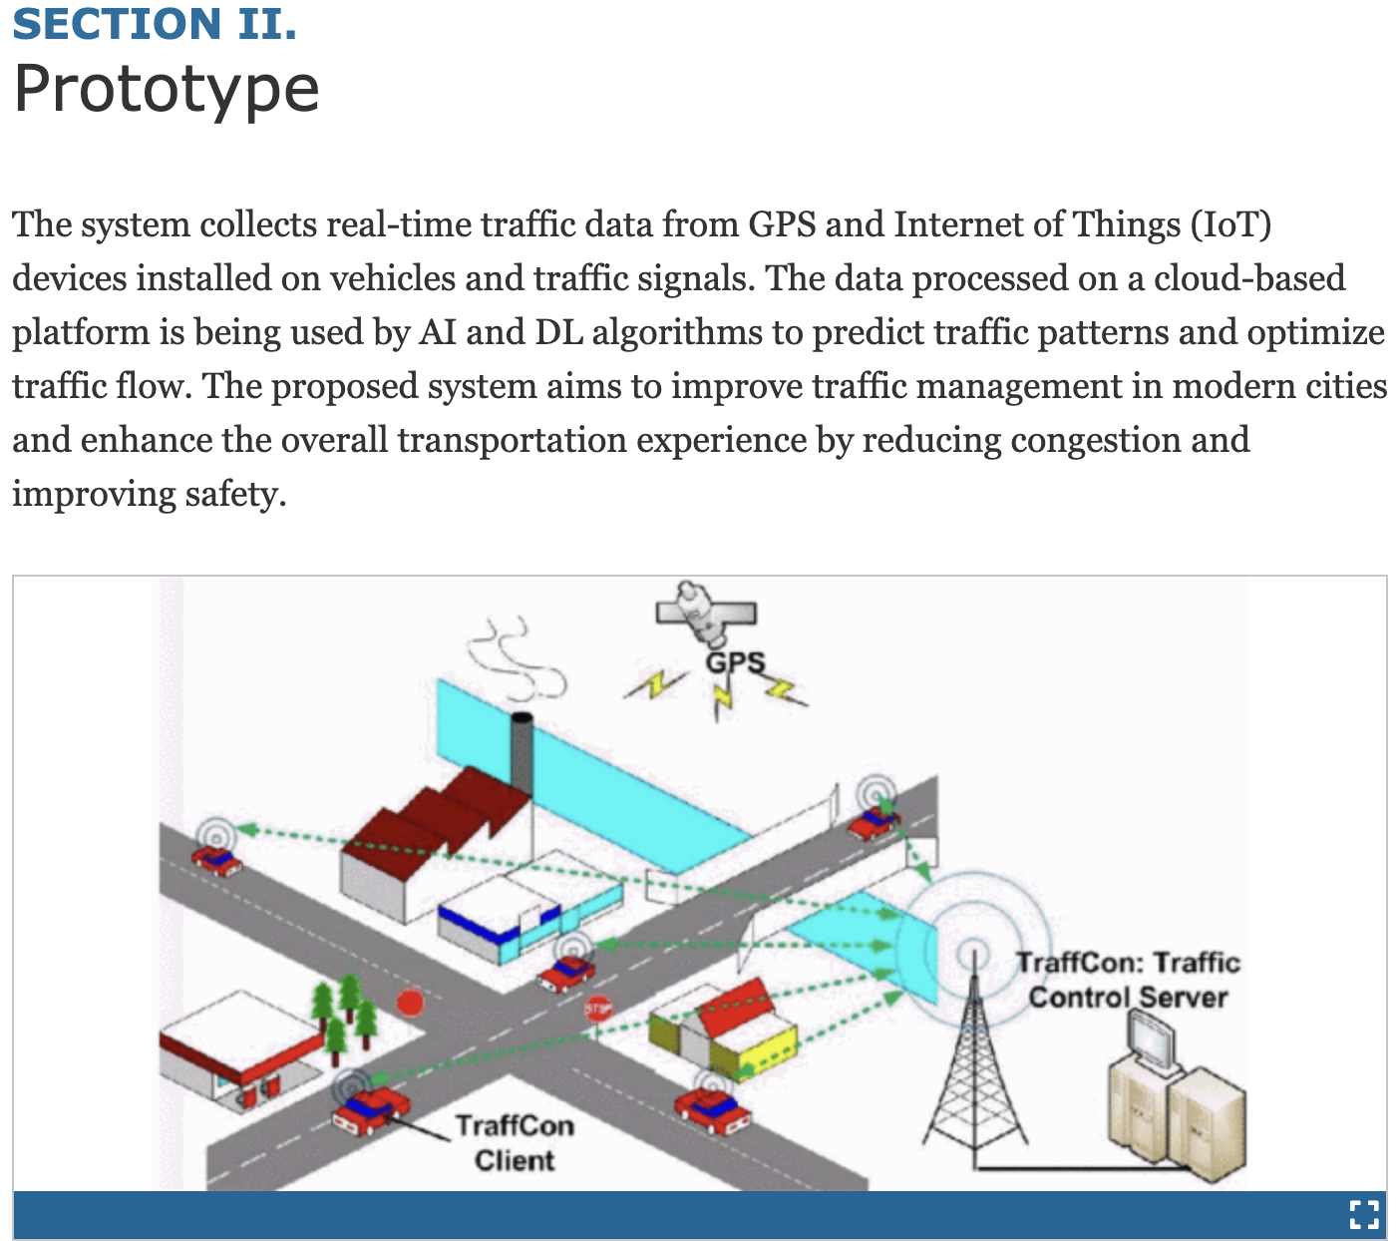

→ Lacks in content quantity

~ Could be used simply for ideas / inspiration

**Citation:**

****TY - CONF

TI - Intelligent Traffic Monitoring, Prioritizing and Controlling Model based on GPS

T2 - 2023 International Conference on Innovative Data Communication Technologies and Application (ICIDCA)

SP - 297

EP - 299

AU - M. C

AU - B. Jyothi

AU - A. Ramagiri

AU - S. Gottipati

AU - V. Jahnavi

AU - S. A. Akther

AU - R. Chinnaiyan

PY - 2023

DO - 10.1109/ICIDCA56705.2023.10100296

JO - 2023 International Conference on Innovative Data Communication Technologies and Application (ICIDCA)

IS -

SN -

VO -

VL -

JA - 2023 International Conference on Innovative Data Communication Technologies and Application (ICIDCA)

Y1 - 14-16 March 2023

ER -

1. **Traffic Prediction for Intelligent Transportation System using Machine Learning**

[**Traffic Prediction for Intelligent Transport System using Machine Learning**](https://ieeexplore.ieee.org/document/9091758)

→This paper aims to develop a tool for predicting accurate and timely traffic flow Information

~Could be used for for reference when conceptualising and testing my own systems

~Tool is probably useless but the methodology and approach to the paper is relevant to me

→February 2020 - Slightly outdated

→ Also Lacks in content quantity

~ Could also be used simply for ideas / inspiration

TY - CONF

TI - Traffic Prediction for Intelligent Transportation System using Machine Learning

T2 - 2020 3rd International Conference on Emerging Technologies in Computer Engineering: Machine Learning and Internet of Things (ICETCE)

SP - 145

EP - 148

AU - G. Meena

AU - D. Sharma

AU - M. Mahrishi

PY - 2020

DO - 10.1109/ICETCE48199.2020.9091758

JO - 2020 3rd International Conference on Emerging Technologies in Computer Engineering: Machine Learning and Internet of Things (ICETCE)

IS -

SN -

VO -

VL -

JA - 2020 3rd International Conference on Emerging Technologies in Computer Engineering: Machine Learning and Internet of Things (ICETCE)

Y1 - 7-8 Feb. 2020

ER -

